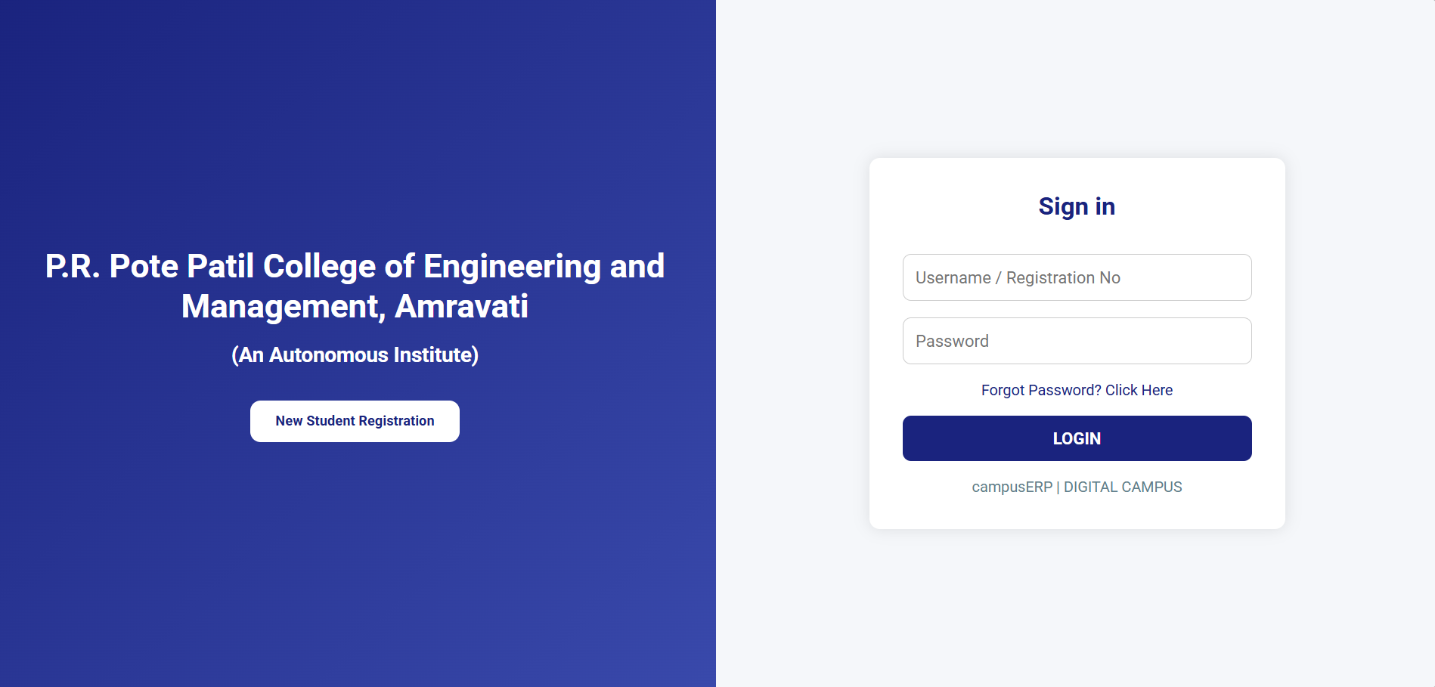

**1. Primary Colors:**

* **Navy Blue (#1A237E)** – For headers, buttons, and highlights. It conveys professionalism and trust.
* **Sky Blue (#29B6F6)** – For accents, icons, or hover states. It adds freshness and modernity.

Reference for animation:

<https://www.halo-lab.com/blog/best-website-animation-techniques>